E45 Third Midterm Review Sheet

|  |  |  |  |  |
| --- | --- | --- | --- | --- |
| **lThe 7 lattice systems** | **The 14 Bravais lattices** | | | |
| Triclinic | [Triclinic](http://en.wikipedia.org/wiki/File:Triclinic.svg) |  |  |  |
| Monoclinic | simple | base-centered |  |  |
| [Monoclinic, simple](http://en.wikipedia.org/wiki/File:Monoclinic.svg) | [Monoclinic, centred](http://en.wikipedia.org/wiki/File:Monoclinic-base-centered.svg) |  |  |
| Orthorhombic | simple | base-centered | body-centered | face-centered |
| [Orthohombic, simple](http://en.wikipedia.org/wiki/File:Orthorhombic.svg) | [Orthohombic, base-centred](http://en.wikipedia.org/wiki/File:Orthorhombic-base-centered.svg) | [Orthohombic, body-centred](http://en.wikipedia.org/wiki/File:Orthorhombic-body-centered.svg) | [Orthohombic, face-centred](http://en.wikipedia.org/wiki/File:Orthorhombic-face-centered.svg) |
| Tetragonal | simple |  | body-centered |  |
| [Tetragonal, simple](http://en.wikipedia.org/wiki/File:Tetragonal.svg) |  | [Tetragonal, body-centred](http://en.wikipedia.org/wiki/File:Tetragonal-body-centered.svg) |  |
| Rhombohedral | [Rhombohedral](http://en.wikipedia.org/wiki/File:Rhombohedral.svg) |  |  |  |
| Hexagonal | [Hexagonal](http://en.wikipedia.org/wiki/File:Hexagonal_lattice.svg) |  |  |  |
| Cubic | simple |  | body-centered | face-centered |
| [Cubic, simple](http://en.wikipedia.org/wiki/File:Cubic.svg) | [Cubic, body-centred](http://en.wikipedia.org/wiki/File:Cubic-body-centered.svg) | [Cubic, face-centred](http://en.wikipedia.org/wiki/File:Cubic-face-centered.svg) |

Q is the activation energy

diffusion of carbon in iron (BCC/FCC) > self-diffusion of iron in iron (BCC/FCC), **higher diffusion coefficient** (D), smaller slope (**smaller activation energy**, occurring more readily)

**carbon** diffuses **interstitially** (more rapid, lower activation energy), **iron** diffuses **substitutionally** by a **vacancy** mechanism.

Diffusion of any type in BCC structure (less densely packed, lower activation energy) occurs more readily than in FCC structure.

|  |  |
| --- | --- |
| **Inter-diffusion** | **Self-diffusion** |
| Substitutional diffusion | Interstitial diffusion    Interstitial atoms are smaller and more mobile. More empty positions than vacancies |
|  | |

**Creep deformation**

|  |  |
| --- | --- |
| File:3StageCreep.svg | **Primary**- the strain rate is relatively high, but slows with increasing time due to work hardening.  **Secondary**- the strain rate reaches a minimum and becomes near constant, due to the balance between work hardening and annealing.  **Tertiary**- the production of dislocations is too significant. The strain rate increases exponentially because of necking.  Grain boundary sliding will be aggravated by more grain boundaries, offering a larger interfacial area over which sliding can occur. Since small grained materials have larger grain boundary area, they are more likely to suffer creep. Therefore it is more desirable to design creep-resistant ceramics having larger grains. |

**Phases and components**

**Phase**- physically distinct, homogeneous, body of matter with definable boundaries

**Component**- distinct chemical constituent form which phases are formed

**Degrees of freedom**- independent variables available to a system; if varied, cause phase changes

**Gibbs Phase Rule**, F = C – P + 2 F = C – P + 1 for fixed pressure (typically the case)

|  |  |  |
| --- | --- | --- |
| Binary isomorphous system    Substitutional and interstitial | **Hume-Rothery rules**  Atomic size effect (<= 15% difference in atomic radii)  Structure effect (same Bravais lattice, same crystal structure)  Electronegativity effect (attraction for electrons)  Valency effect (same oxidation state) | |
| http://upload.wikimedia.org/wikipedia/commons/thumb/8/8e/Lever_rule.svg/400px-Lever_rule.svg.png |  |
|  | C = 1 on two ends of the phase diagram. C = 2 anywhere else  P = 1 in one phase region (liquid, apha, beta, gamma, etc.)  P = 2 in two phase region | |

**Eutectic system**

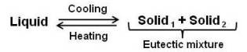

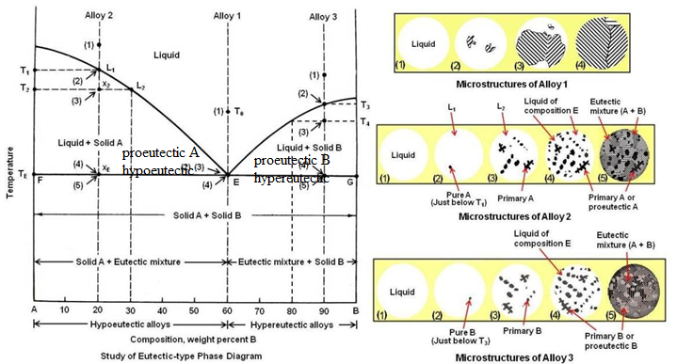

|  |  |
| --- | --- |
|  | Solidification of Alloy 1 |

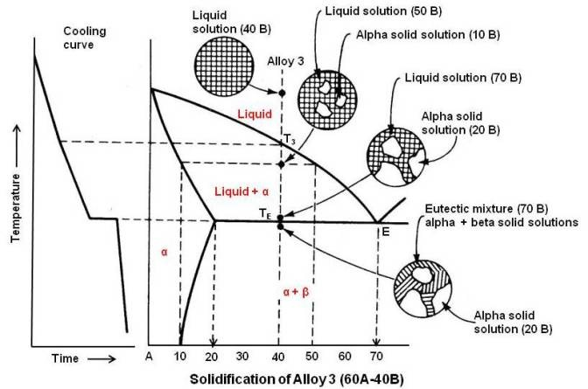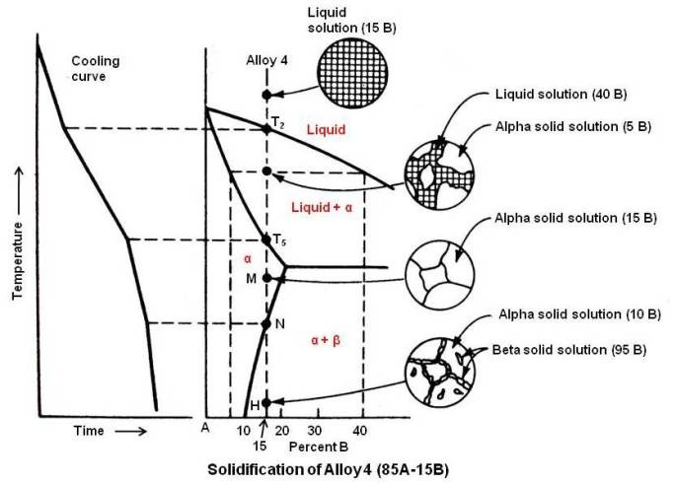

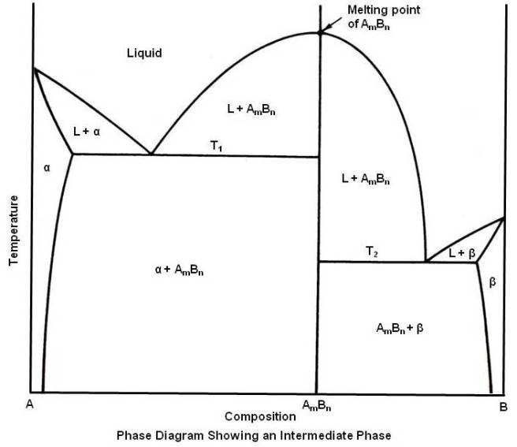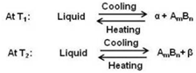

**Peritectic reaction**  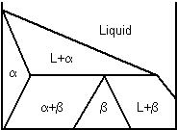 L + alpha 🡪 beta 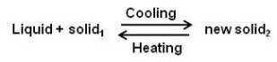

**Peritectoid reaction** 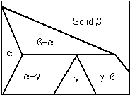 alpha + beta 🡪 gamma 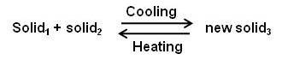

**Eutectoid reaction** 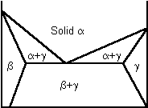 alpha 🡪 beta + gamma 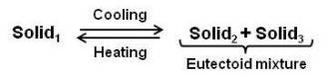

|  |  |
| --- | --- |
|  |  |

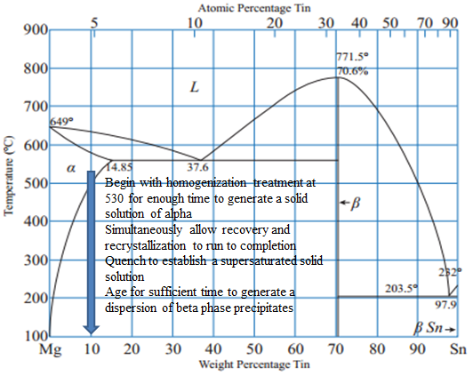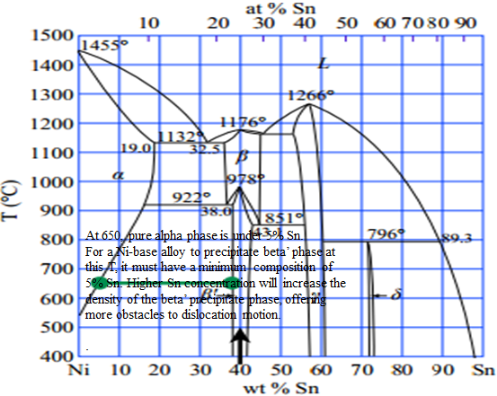

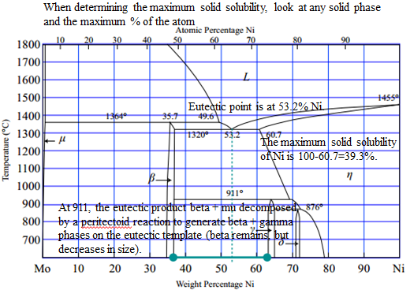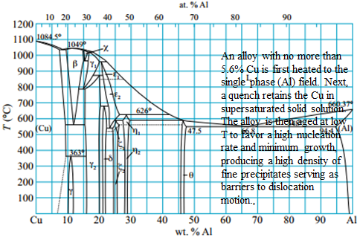

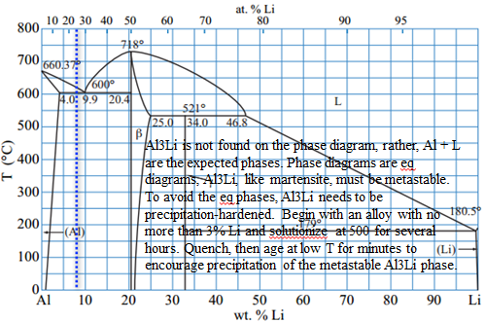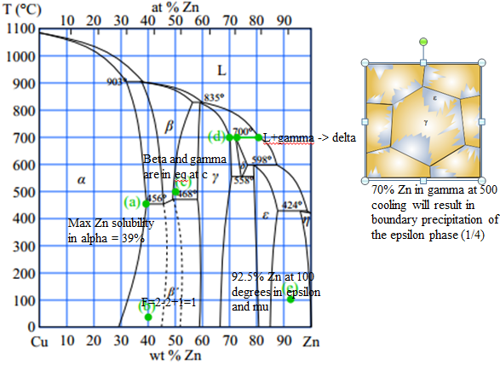

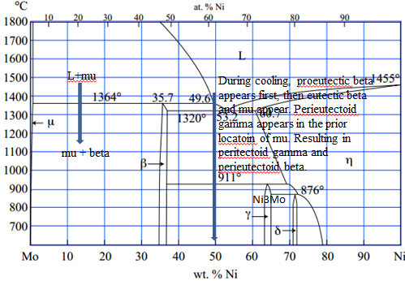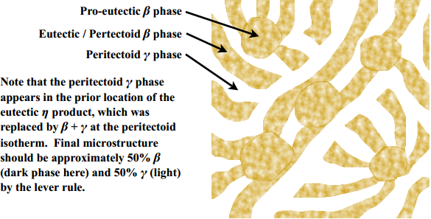

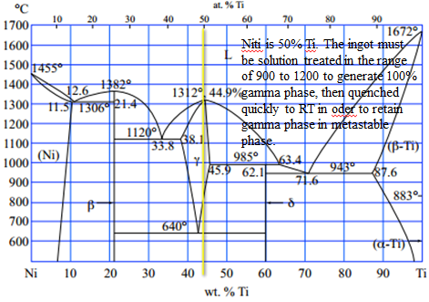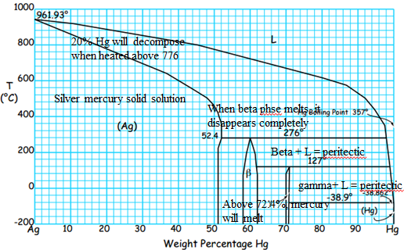

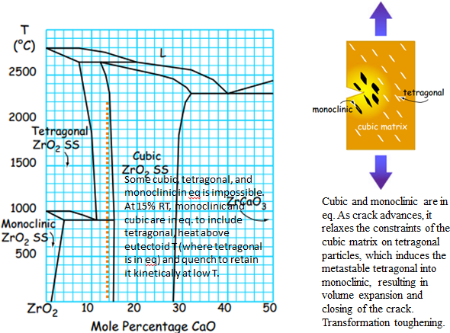

|  |  |  |  |  |
| --- | --- | --- | --- | --- |
|  | | | Coarse pearlites are formed at high temperatures and are generally softer, because the grain size is big, allowing for more defect motion. At high temperatures the supersaturation is low, so the driving force for the emergence of new phase is low, causing fewer nuclei, but since diffusion is favored, the few nuclei grow very quickly. The result is a coarse microstructure.  Fine pearlites are formed at low temperatures and are generally harder, because the grain size is small, allowing for less defect motion. At low temperatures supersaturation is high, generating a high driving force and nucleation, but since diffusion is hindered, growth is hindered, resulting in a fine microstructure. | |
|  | | quench to 650 and wait (at least 20 s) to form coarse pearlite  quench to 500 and wait (at least 10 s) to form fine pearlite (soft and ductile)  quench to 350 and wait (at least 1000 s) to form bainite (fine needles)  quench to room temperature to form martensite immediately  to create X% martensite, Y% fine pearlite, Z% bainite  quench to 500 and wait to transform Y% of austenite to fine pearlite  quench to 350 and wait and transform Z/(1-Y%) of remaining austenite to bainite  quench remaining to marteniste | | |
| http://www.gowelding.com/met/carbon1.gif | | Carbon is soluble in the FCC phase of Fe (austenite or gamma-Fe) up to 2%  Carbon is soluble in the BCC phase of Fe (ferrite or alpha-Fe) up to 0.02%  When austenite is cooled below 727 the eutectoid T, it becomes unstable. The transformation of austenite requires redistribution of C atoms from a random solid solution to one in which all C is contained in the Fe3C precipitates. Just below eutectoid T, the driving force is low. The lower T, the greater the driving force, causing a higher nucleation rate. Below 540, the rate of transformation decreases again because C atoms become less mobile in austenite. If FCC austenite is quenched, it changes instantly by a shear mechanism to a BCT structure, trapping C in martensite. | | |
| **austempering** | **martempering** | | | **Interrupted quench** |
| Tempering is a low T thermal treatment to restore some ductility by allowing carbon diffusion, precipitation of carbides, and restoration of a cubic structure with more slip systems than the tetragonal martensitic structure, allowing the final part to withstand even aggressive impact loading. | | | | |

**Thermal treatment**

* thermal shock is a consequence of: **thermal expansion** (alpha = 1/L * dL/dT**) and thermal conductivity** (dQ/dt =-kA dT/dx)
* **differential thermal expansion** between **surface** and **interior** leads to failure of a component placed in a steep T gradient
* differential because poor thermal conductivity which prohibits heat flow that would flatten the T gradient
* **by reducing the T gradient** from **surface** to **interior**, we **slow thermal contraction at the surface** and **reduce thermal contraction at the surface relative to the interior**.
  + placing hot glassware on a dry potholder **retains heat at the surface**, reducing the T gradient from surface to interior
  + never putting glassware directly on a burner or under a broiler **separates the glassware from the high heat source**, reducing the T gradient from surface to interior.
  + allowing the oven to fully preheat before placing the glassware in the oven **immerses the glassware in a high T** environmentrather than allowing it slowly heat as the oven T increases, increasing the T gradient from surface to interior

|  |  |
| --- | --- |
| **sintering,** full density requires:   * high pressure to increase contact between particles and high T to enhance diffusion kinetics * long times in the sintering furnace to complete the densification process * grain refiners (chemical agents that “pin” grain boundaries to restrict rapid grain growth) | **sintering to produce porous materials**   * large particle size- the size of pore scales with the initial particle size * no compaction- the pores will remain open longer throughout the firing process * low sintering T- the less diffusional bonding will occur, generating necks between sintered particles as needed for strength, but preserving adequate pore volume * short sintering time- diminishes the chance for pore closure |

**Failure of engineering materials**

$K_{IC}=\sqrt{πa}σ_{f} \left(fracture stress\right) K_{IC}$ is stress-intensity factor; a is crack length.

**Metallic alloys deform by dislocation motion**. **Large grains offer few barriers to dislocation**, enable metallic alloys to deform readily, raising the amount of stress that can be accommodated before fracture. **Larger grains = larger KIC**

**Ceramics do not deform by dislocation motion**, but can accommodate some stress by microcracks before failure. **Small grains** enable more microcracks along weaker grain boundaries that can dissipate failure by **crack deflection and effective crack blunting (microcrack toughening)**. **Smaller grains = larger KIC**

**A fatigue crack initiates when dislocations intersect the free surface**. To initiate a surface crack, dislocation motion is required.

**Glass ceramics are aged to precipitate a crystalline phase.**

$$σ_{m}\left(maximum stress at the tip of a crack of length\right)=2σ(tensile stress)\sqrt{\frac{a (crack length)}{p (crack tip radius)}}$$

Microcracks in ceramic materials dissipate the energy release during **crack growth by dispersing the fracture over many internal sites**. Moreover, when the primary crack joins up with the microcracks ahead of it, the primary crack is blunted, **increasing the crack tip radius**, reducing the maximum stress at the crack tip.

**Cold working**

* Cold work reduces dislocation by adding barriers to that motion (creating more dislocations).
* Cold working increases fatigue strength by inhibiting crack invitation.
* Cold working decreases the T at which recrystallization occurs by creating dislocations and sites for recrystallization.

**Three stages of annealing**

* **Purpose:** to remove damage from cold work

1. **Recovery**

* Annihilation of point defects
* Dislocation **polyganization** (subgrain boundaries)
  + because of low T of the dislocations are more mobile, they tend to pile up to lower the strain energy of the system
  + the arrangement of excess dislocations into low angle tilt boundaries (misorientations of a few degrees).
  + leads to the formation of sub-grains
* Driven by reduction in strain energy

1. **Recrystallization**
   * **Driven by reduction in strain energy**
   * Crystallization reaction of new strain-free grains that consume the little heavily dislocated grains behind them
   * New dislocation-free grains nucleate and replace the deformed grains with high dislocation density.

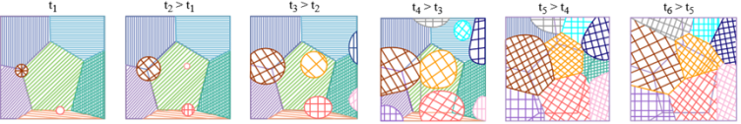

1. **Grain growth**

* **Driven by reduction in surface energy**
* Recrystallization and grain growth are enhanced by diffusion, a thermally-activated process.
* As T increases, diffusion is favored, the rate of both recrystallization and grain growth increases.

Strength on a microstructural scale is resistance to the nucleation and migration (slip) of dislocations. Grain boundaries act as barriers to dislocation motion by disrupting the continuity of slip planes; the more grain boundaries appearing in the path of mobile dislocations, the greater the number of impediments to their motion. Consequently, fine grained microstructures with their higher density of grain boundaries resist dislocation motion more than coarse grain microstructures.

|  |  |
| --- | --- |
|  | **Homogenous nucleation**- precipitation occurs within a completely homogenous medium, precipitation of a single-phase solid within a liquid matrix  **Heterogeneous nucleation**- precipitation occurs at some structural imperfection such as a foreign surface  total rate of forming solid is product of **nucleation rate (favored at low T) and growth rate (favored at high T)**  transformation rate from nucleation and growth rates |

**Annealing**

* restores ductility by removing damage caused by cold work
* requires elevating temperature to enable diffusion, 1/3 to 1/2 of the melting temperature
* annealing to the point of excessive grain growth can soften the material
* **age-hardening -** changes in solid solubility with temperature to produce fine particles of an impurity phase, which impede the movement of dislocations, or defects in a crystal's lattice
* When metallic alloys are quenched following a homogenization treatment in a single-phase region of the phase diagram, **a supersaturated solution results, and the alloy is ready for aging.**

**In terms of strength:**

|  |  |
| --- | --- |
| Solution-treated, artificially aged, cold worked  Solution-treated, cold worked, naturally aged  Solution treated, artificially aged  Strain-hardened  Strain-hardened + annealed | Solution treatment enhances strength  Artificially aged > naturally aged  Cold work enhances strength  Annealing softens the material |
| **Strengthened by**  Cold working  Alloying  **Phase transformations** – precipitation hardening, carefully controlled thermal treatments, beginning with homogenization in a single phase field, followed by a rapid quenching to generate a supersaturated solid solution, finishing with an aging treatment to produce a fine dispersion of second phase particles that impede dislocation motion | **Weakened by**  Porosity (casting)  Annealing  Welding  **Phase transformation** – not carefully controlled thermal treatments, slow cooling from the homogenization temperature, detrimental distribution of second phase particles occurring exclusively at grain boundaries. There are no precipitate particles and solute atoms. serve as obstacles to dislocation motion. |

**Work hardening** generates a high density of dislocations. Subsequent age hardening employs an elevated T to encourage diffusion and precipitate growth, but the precipitates are most likely to **nucleate heterogeneously** on the existing dislocations, **reducing precipitate density** and dispersion compared to a homogenously-nucleated product. Moreover, diffusion will also cause some annealing, removing some of the original dislocations in the microstructure.

**Age hardening** in the absence of dislocations generates a **homogenously-nucleated product with high density and uniform dispersion**. Subsequent work hardening adds dislocations to the microstructure that are themselves pinned by the existing precipitate dispersion. The stronger alloy results from **age hardening because of its overall higher density of obstacles.**

|  |  |  |  |  |  |  |  |
| --- | --- | --- | --- | --- | --- | --- | --- |
|  | Soft, viscous flow form, lying flat. No stress. | | | | | When the glass is too hot, its surface cannot be cooled below Tg during the surface quench. The surface will not be in temporary tension but will readily deform to **relax all stress gradients**. As the glass cools slowly to RT, all of it passes through Tg at the same time, again relaxing all stress gradients. No compression on surface, no interior tension, no residual stress. | |
| Below Tg, both surfaces cool (but interior is still hot). Surface contracts while interior expands.  Interior is in compression (squeezed).  Exterior is in tension (pushed outwards). | | | | |
| After surface cooling, interior starts to cool, but surface wants to maintain its position because it’s already cool.  Interior is in tension (pushed outwards by surface).  Exterior is in compression (squeezed by interior contraction). | | | | |
|  | | | | | |  | |
| **Blockcopolymers**  –AAAAABBBBBBBAAAAA  –sequences or blocks of each monomer | | | | **Graft copolymers**  –blocks of one monomer are grafted as branches onto the other  –AAAAAAAAAAAAA  B B  B B | | | |
|  | | | | At low T, ABS has a higher elastic modulus than PC because of the acrylonitrile and styrene grafts extending off butadiene backbone, colliding with one another and obstructing the relative motion of ABS chains past during elastic deformation. PC has much less steric hindrance because it has no such extensions protruding from the backbone chain.  Increasing T: diffusional motion enables the grafts to more easily evade one another during uncoiling and sliding, generating a lower Tg in ABS than PC. Interpenetration of chains from PC and ABS constituents increased rigidity and resistance to chain uncoiling and sliding. | | | |
| Isotactic - same side | | Syndiotactic – alternating | | | | | Atatic – random |
| **Condensation**   * Molecules join by losing a molecule * step growth * monomers with functional groups * polyesters, polyacetals, polyamides, polyurethane | | | **Addition**   * repeat unit has the same composition as the monomer * chain growth * molecules bond to form a chain, no loss * PE, PVC, PTFE, PS, PMMA, Nylon-6, PP | | | | |
|  | | | Not enough space for all 6 C on the phenol ring to simultaneously connectd to other phenols. Connecting every other C is possible, trifunctional  **Steric hindrance** | | | | |
|  | | | The double carbon bond suggests that initiation causes a bifunctional mer, leading to **chain growth by addition** polymerization up to a DOP of n. | | | | |
|  | | | Cross-linking joins mers from adjacent backbone chains by covalent bonding, **preventing any lateral sliding** of those chains past one another, **increasing rigidity and elevating the modulus at all T.**  Branching **inhibits** but doesn’t prevent the sliding.  Viscoelastic deformation  Uncoiling of chains 🡪 sliding (vdW bonds break) 🡪 stretching of covalent bonds  Glass transition temperature marks the transition from rigid “crystal-like” to viscous “glass-like” mechanical behavior. Crystals deform by dislocation motion. Glasses deform by viscous flow. At the melting point, elastic modulus drops to 0. | | | | |
|  | | | Elastomers and thermoplastics are readily formed into complex shapes by flow or injection molding at high T and recyclable  Elastomeric deformation | | | | |
|  | | | Elastic returns to original state after strain is removed.  Viscous doesn’t return to original state after strain is removed, so it is permanently deformed.  Viscoelastic recovers to original state slowly. | | | | |
| **Thermoplastic polymers**   * Plastic at T * Linear polymers * Thermal activation (Arrhenius) * Ductility reduced by coiling * recyclable | | | **Thermosetting polymers**   * set by T * network polymer * step-growth process (facilitated at high T) * not recyclable | | | | |
| http://www.daviddarling.info/images/vulcanization.png **vulcanization** | | | | | http://upload.wikimedia.org/wikipedia/commons/thumb/8/82/ABS_resin_formula.PNG/1024px-ABS_resin_formula.PNG  **ABS – acrylonitrile-butadiene-styrene** | | |

Polymers typically show no clear transition between elastic plastic deformation and no clear ultimate tensile strength (necking behavior). Deformation in polymers begins by the uncoiling and sliding of polymer chains past one another as weak secondary vdW bonds are broken. This accounts for the low strength of polymers. A dislocation model of plasticitiy is NOT appropriate for polymers lack crystallinity. Failure ultimately occurs when polymer chains are separated as elongation and sliding reach their physical limits.

**Molecular length**

* Root mean square length L = l $\sqrt{m}$ m is number of bonds l is length of a single bond
* Extended length $L_{ext}=ml\sin{54.75}$

|  |  |
| --- | --- |
|  | $$flexural strength=\frac{3FL}{2wh^{2}}$$ $$flexural modulus=\frac{{mL}^{3}}{4wh^{3}}$$ |